Gap Analysis:
Assessment and Management of Venous Leg Ulcers, Revised March 2007
Work Sheet

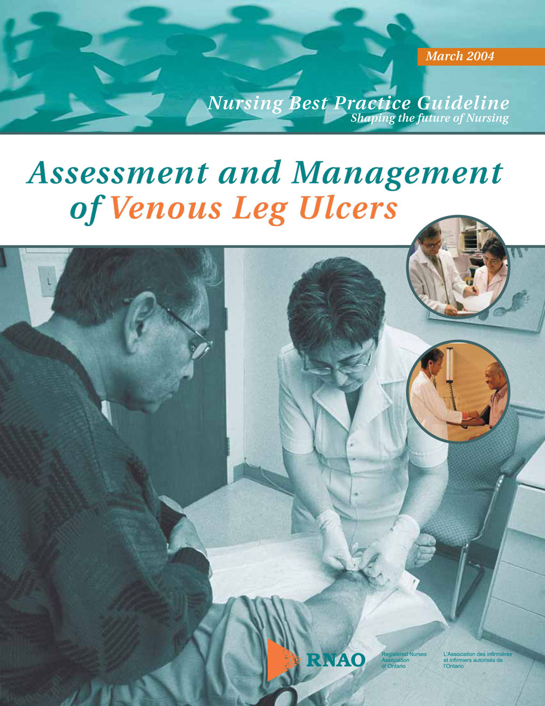

This guideline can be downloaded for free at:
http://rnao.ca/bpg/guidelines/assessment-and-management-venous-leg-ulcers

The RNAO Leading Change Toolkit 3rd Edition
https://rnao.ca/leading-change-toolkit

Date Completed:
Team Members participating in the Gap Analysis:

Completion of this gap analysis allows for the annual comparison of your current practice to evidence-based practices as regulated by the MOHLTC per Fixing Long-Term Care Act, 2021 at https://www.ontario.ca/laws/statute/21f39 &
O. Reg. 246/22: GENERAL (ontario.ca)

RNAO Best Practice Guideline Recommendations | Met | Partially Met | Unmet | Notes  (Examples of what to include: is this a priority to our home, information on current practice, possible overlap with other programs or partners)
Practice Recommendations: Comprehensive Assessment
1.0 Assessment and clinical investigations should be undertaken by healthcare professional(s) trained and experienced in leg ulcer management.
(Level of Evidence= C)
2.0 A comprehensive clinical history and physical examination includes:
- blood pressure measurement;
- weight;
- blood glucose level;
- doppler measurement of Ankle Brachial Pressure Index (ABPI);
- any other tests relevant to presenting patient’s condition;
- ulcer history;
- ulcer treatment history;
- medical history;
- medication;
- bilateral limb assessment;
- pain;
- nutrition;
- allergies;
- psychosocial status (including quality of life); and
- functional, cognitive, emotional status and ability for self-care. The above should be documented in a structured format for a client presenting with either their first or recurrent leg ulcer and should be ongoing thereafter.
(Level of Evidence= C)
3.0 A comprehensive assessment of an ulcer should include:
- measurement of the wound and undermining;
- amount and quality of exudate;
- wound bed appearance;
- condition of the wound edge;
- infection;
- presence or absence of patient suffering; and
- re-evaluation.
(Level of Evidence= C)
Measure the surface areas of ulcers, at regular intervals, to monitor progress. Maximum length and width, or tracings onto a transparency are useful methods.
(Level of Evidence= B)
4.0 Regular ulcer assessment is essential to monitor treatment effectiveness and healing goals.
(Level of Evidence= C)
Practice Recommendations: Diagnostic Evaluation
5.0 An Ankle Brachial Pressure Index (ABPI) measurement should be performed by a trained practitioner to rule out the presence of peripheral arterial disease, particularly prior to the application of compression therapy.
(Level of Evidence = B)
6.0 An Ankle Brachial Pressure Index (ABPI) >1.2 and <0.8 warrants referral for further medical assessment.
(Level of Evidence = C)
7.0 Prior to debridement, vascular assessment, such as Ankle Brachial Pressure Index (ABPI), is recommended for ulcers in lower extremities to rule out vascular compromise and ensure healability.
(Level of Evidence = C)
Practice Recommendations: Pain
8.0 Pain may be a feature of both venous and arterial disease, and should be addressed.
(Level of Evidence = B)
9.0 Prevent or manage pain associated with debridement. Consult with a physician and pharmacist as needed.
(Level of Evidence = C)
Practice Recommendations: Venous Ulcer Care
10.0 Develop treatment goals mutually agreed upon by the patient and healthcare professionals, based on clinical findings, current evidence, expert opinion and patient preference.
(Level of Evidence = C)
11.0 Local wound bed preparation includes debridement when appropriate, moisture balance and bacterial balance.
(Level of Evidence = C)
12.0 Cleansing of the ulcer should be kept simple; warm tap water or saline is usually sufficient.
(Level of Evidence = B)
13.0 First-line and uncomplicated dressings must be simple, low adherent, acceptable to the client and should be cost-effective.
(Level of Evidence = A)
14.0 Avoid products that are known to cause skin sensitivity, such as those containing lanolin, phenol alcohol, or some topical antibiotic and antibacterial preparations.
(Level of Evidence = C)
15.0 Choose a dressing that optimizes the wound environment and patient tolerance.
(Level of Evidence = C)
16.0 No specific dressing has been demonstrated to encourage ulcer healing.
(Level of Evidence = A)
17.0 In contrast to drying out, moist wound conditions allow optimal cell migration, proliferation, differentiation and neovascularization.
(Level of Evidence = A)
18.0 Refer clients with suspected sensitivity reactions to a dermatologist for patch testing. Following patch testing, identified allergens must be avoided, and medical advice on treatment should be sought.
(Level of Evidence = B)
19.0 Venous surgery followed by graduated compression hosiery is an option for consideration in clients with superficial venous insufficiency.
(Level of Evidence = A)
Practice Recommendations: Infection
20.0 Assess for signs and symptoms of infection (Level of Evidence = A)
21.0 Manage wound infection with cleansing and debridement, as appropriate. Where there is evidence of cellulitis, treatment of infection involves systemic antibiotics.
(Level of Evidence = B)
22.0 The use of topical antiseptics to reduce bacteria in wound tissue should be reserved for situations in which concern for bacterial load is higher than that of healability.
(Level of Evidence = C)
Practice Recommendations: Compression
23.0 The treatment of choice for venous ulceration uncomplicated by other factors is graduated compression bandaging, properly applied and combined with exercise. (Level of Evidence= A)
- In venous ulceration, high compression achieves better healing than low compression. (Level of Evidence= A)
- Compression bandages should only be applied by a suitably trained and experienced practitioner. (Level of Evidence = B)
- The concepts, practice, and hazards of graduated compression should be fully understood by those prescribing and fitting compression stockings. (Level of Evidence = B)
- Ankle circumference should be measured at a distance of 2.5 cm (one inch) above the medial malleolus. (Level of Evidence = C)
24.0 External compression applied using various forms of pneumatic compression pumps can be indicated for individuals with chronic venous insufficiency.
(Level of Evidence = A)
25.0 The client should be prescribed regular vascular exercise by means of intensive controlled walking and exercises to improve the function of the ankle joint and calf muscle pump.
(Levels of Evidence =A)
Practice Recommendations: Complementary Therapies
26.0 Consider electrical stimulation in the treatment of venous leg ulcers.
(Level of Evidence = B)
27.0 Therapeutic ultrasound may be used to reduce the size of chronic venous ulcers.
(Level of Evidence = A)
Practice Recommendations: Reassessment
28.0 If signs of healing are not evident, a comprehensive assessment and re-evaluation of the treatment plan should be carried out at three month intervals, or sooner if clinical condition deteriorates.
(Level of Evidence = C)
29.0 For resolving and healing venous leg ulcers, routine assessment at six-month intervals should include:
- physical assessment;
- Ankle Brachial Pressure Index (ABPI);
- replacement of compression stockings; and
- reinforcement of teaching.
(Level of Evidence = C)
Practice Recommendations: Client Education for Secondary Prevention
30.0 Inform the client of measures to prevent recurrence after healing:
- daily wear of compression stockings, cared for as per manufacturer’s instructions and replaced at a minimum every six months;
- discouragement of self-treatment with over-the-counter preparations;
- avoidance of accidents or trauma to legs;
- rest periods throughout the day with elevation of affected limb above level of heart;
- early referral at first sign of skin breakdown or trauma to limb;
- need for exercise and ankle-joint mobility;
- appropriate skin care avoiding sensitizing products; and
- compression therapy for life with reassessment based on symptoms.
(Level of Evidence = C)
Education Recommendations:
31.0 Guidelines are more likely to be effective if they take into account local circumstances and are disseminated by an ongoing education and training program.
(Level of Evidence = C)
32.0 Using principles of adult learning, present information at an appropriate level for the target audience, including healthcare providers, clients, family members and caregivers.
(Level of Evidence = C)
33.0 All healthcare professionals who manage lower limb ulcers should be trained in leg ulcer assessment and management.
(Level of Evidence = C)
34.0 Design, develop, and implement educational programs that reflect a continuum of care. The program should begin with a structured, comprehensive, and organized approach to prevention and should culminate in effective treatment protocols that promote healing as well as prevent recurrence.
(Level of Evidence = C)
35.0 Education programs for healthcare professionals who manage lower limb ulcers should include:
- pathophysiology of leg ulceration;
- leg ulcer assessment;
- need for Doppler ultrasound to measure Ankle Brachial Pressure Index (ABPI);
- normal and abnormal wound healing;
- compression therapy theory, management, and application;
- dressing selection;
- principles of debridement;
- principles of cleansing and infection control;
- skin care of the lower leg;
- peri-wound skin care and management;
- psychological impact of venous stasis disease;
- quality of life;
- pain management;
- teaching and support for care provider;
- health education;
- preventing recurrence;
- principles of nutritional support with regard to tissue integrity;
- mechanisms for accurate documentation and monitoring of pertinent data, including treatment interventions and healing progress; and
- criteria for referral for specialized assessment.
(Level of Evidence = C)
36.0 Healthcare professionals with recognized training in leg ulcer care should mentor and transfer their knowledge and skills to local healthcare teams.
(Level of Evidence = C)
37.0 The knowledge and understanding of the healthcare professional is a major factor in adherence to treatment regimens.
(Level of Evidence = C)
Organization and Policy Recommendations:
38.0 Successful implementation of a venous ulcer treatment policy/strategy requires:
- dedicated funding
- integration of healthcare services
- support from all levels of government
- management support
- human resources
- financial resources
- functional space
- commitment
- collection of baseline information about vulnerable populations
- resources and existing knowledge ■ interpretation of above data and identification of organizational problems.
(Level of Evidence = C)
39.0 Nursing best practice guidelines can be successfully implemented only where there are adequate planning, resources, organizational and administrative support, as well as appropriate facilitation. Organizations may wish to develop a plan for implementation that includes:
- An assessment of organizational readiness and barriers to education.
- Involvement of all members (whether in a direct or indirect supportive function) who will contribute to the implementation process.
- Dedication of a qualified individual to provide the support needed for the education and implementation process.
- Ongoing opportunities for discussion and education to reinforce the importance of best practices.
- Opportunities for reflection on personal and organizational experience in implementing guidelines.
(Level of Evidence = C)

